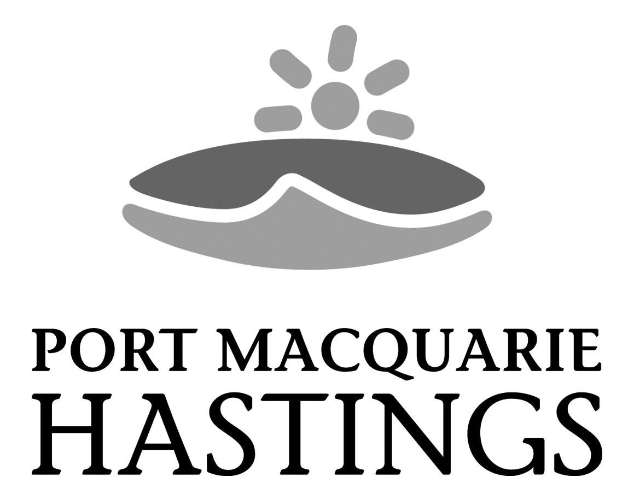

D&E

MEMO

To: | DA2021 - 175 file and PPSNTH-89
cc:
From | Pat Galbraith-Robertson
Date: | 24 August 2021 | Our ref: | DA2021 - 175
Subject: | Clarification of Council assessment report conclusion and statement of reason

Advice provided to Planning Panel’s Secretariat on 24 August 2021 that there has been a regrettable error made in the assessment report conclusion and statement of reason (last page 36 of report).

The following wording should have been provided in the assessment report to align with the remainder of the assessment and recommendations:

CONCLUSION AND STATEMENT OF REASON

The application has been assessed in accordance with Section 4.15 of the Environmental Planning and Assessment Act 1979.

Issues raised during assessment of the application have been considered in the assessment of the application. Where relevant, conditions could be are recommended to manage the impacts attributed to these issues.

The site is not considered suitable for the development as currently proposed and the proposal does not adequately address all relevant planning controls. The development is considered to be contrary to in the public's interest to recommend supporting given the traffic and parking issues identified however and will be unlikely to result a significant adverse social, environmental or economic impact. It is recommended that the application be refused approved subject to the reasons listed earlier in this report.

Apologies for any inconvenience caused.

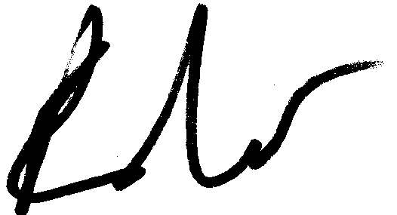
Patrick Galbraith-Robertson
Development Planning Coordinator

24 August 2021

